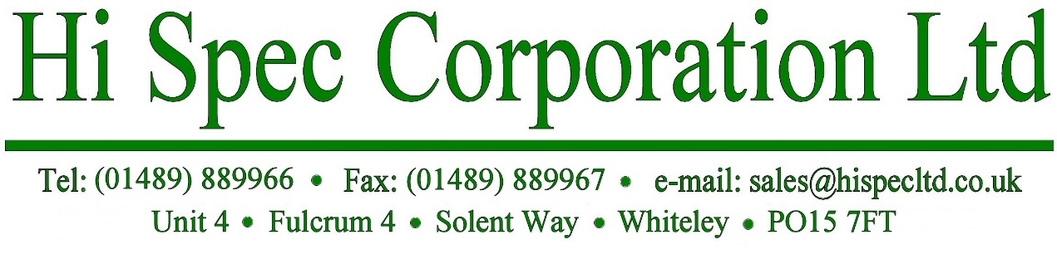

September 2019
2015/863/EU (RoHS 3 Directive)

PCB’s Supplied by Hi Spec Corporation Limited.

All Printed Circuit Boards supplied with the following Surface Finishes:-

Electroless Nickel / Immersion Gold
Immersion Tin
Immersion Silver
Electroplated Gold
Electroless Nickel / Electroless Palladium/ Immersion Gold
Lead Free Hot Air Levelling

Will conform to the Directive (EU) 2015/863 amendment of the RoHS 3 DIRECTIVE
2011/65/EU, RoHS-Recast, Article 4(1): and do not contain any of the below mentioned
10 Hazardous substances.

• Cadmium (Cd)
• Mercury
• Lead (Pb)
• Hexavalent chromium (Cr6+)
• Polybrominated biphenyls (PBB)
• Polybrominated diphenyl ethers (PBDE)
• Bis(2-Ethylhexyl) phthalate (DEHP) (added in 2015)
• Benzyl butyl phthalate (BBP) (added in 2015)
• Dibutyl phthalate (DBP) (added in 2015)
• Diisobutyl phthalate (DIBP) (added in 2015)
If you would like any additional information on “RoHS 3” please contact Robert Allan on +44 (0) 1489 889966 or email sales@hispecltd.co.uk
Best regards
R Allan
Robert Allan
Director

